The Power of Yet: Do You Believe You Can Improve?
by Sam Thomas Davies
A young Glenn Whitman was standing in his driveway, trying to perfect his slapshot: the hardest shot one can perform in ice hockey.
Like most boys who aspire to play professionally, Whitman would spend hours practicing the maneuver, but no matter how hard he tried, he failed to see any improvement.
Annoyed by his apparent lack of progress, Whitman sought comfort in his mum.
“I can’t improve my snapshot!” he proclaimed, “I can’t juggle a soccer ball 100 times and I can’t improve my snapshot!”
His mum listened intently before sending him back to the driveway with something to think about, a lesson she had reminded him of countless times before:
“You can’t do it, yet”.

“Not Yet”
There’s a high school in Chicago with an unorthodox grading system.
Students have to pass a certain number of classes to graduate, and if they don’t pass, they get a different kind of grade: “Not Yet.”
In her TED presentation, “The Power of Believing You Can Improve”, Carol Dweck explains the power of “Not Yet”:
If you get a failing grade, you think, I’m nothing, I’m nowhere. But if you get the grade “Not Yet” you understand that you’re on a learning curve. It gives you a path into the future. [1]
Dweck, a prominent psychologist at Stanford University, is famous for her pioneering research on motivation and personality.
In one study, Dweck wanted to see how children coped with challenge and difficulty by giving 10-year-olds problems that were slightly too hard for them. [2]
“Some of them reacted in a shockingly positive way”, explains Dweck. “They said things like, ‘I love a challenge,’ or, ‘You know, I was hoping this would be informative’”.
These children had what Dweck calls a “growth mindset”. They understood that their abilities could be developed. They didn’t run from error; they engaged with it.
But other students felt it was tragic and catastrophic. They felt their intelligence had been up for judgment and they failed. These children had a “fixed mindset”. They believed their qualities were carved in stone.
In follow-up studies, Dweck learned the children with a fixed mindset were more likely to cheat and look for someone who did worse than they did so they could feel better about themselves.
The children with a fixed mindset were operating from the “now”, whereas the children with a growth mindset were operating from the “Not Yet”.

Do You Have Limiting Beliefs?
Unlike Glenn Whitman, few of us aspire to play for the National Hockey League, but we do have things we want to improve in.
We want to build self-discipline, stick to a change we’re making, get more done, be a better parent, co-worker, friend, sibling … The problem, however, is few of us believe that we can actually improve.
We believe we’re not smart, attractive, rich, old or young enough. Or we don’t have the time, the energy, a supportive family, etc. These are stories we tell ourselves and it’s a consequence of a fixed mindset. We believe we can’t improve or persist in the face of obstacles or learn from criticism.
But the wonderful reality is we can … once we know how.

How to Develop a Growth Mindset
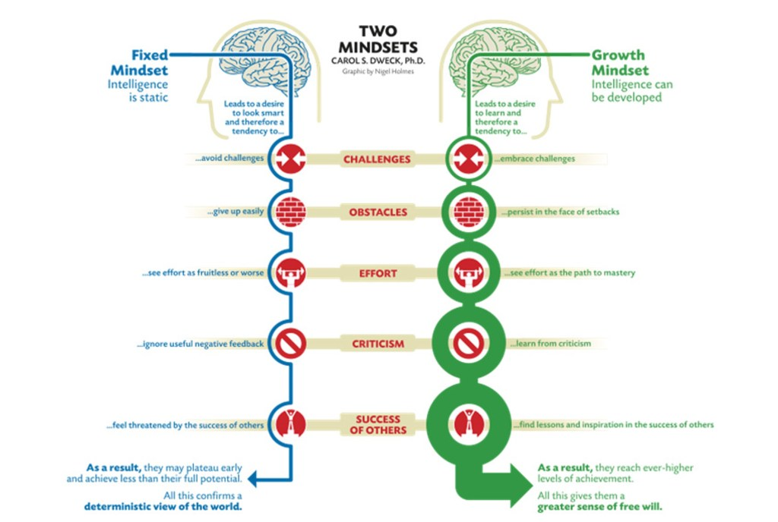Source: www.blogs.oracle.com

If you want to move from a fixed mindset to a growth mindset, you need to believe you can improve, maybe not now, but one day, and develop a “yet sensibility”.
Here’s a 3-step process you can use to do just that.
Step 1. Become mindful of your negative self-talk. If you’re trying to change a habit – say, running in the morning – pay attention to any negative self-talk that surfaces, (especially before you do the habit) and write it down. For example, you might hear, “What’s the point? I tried running before and gave up after a week”. Whatever it is, write it down. Try not to engage with or criticise your self-talk, be present with it and observe.
Step 2. Believe you can change. In order to change any belief, you must believethree things:
- You must believe a belief can change
- You must believe you can change it
- You must believe you can change it, now. Not tomorrow, next week, next month, or next year, but now.
You have a choice. You can either believe a belief can change, you can change it and you can change it, now, or you can believe none of the above. If a belief isn’t serving you, eliminate it. Simple.
Step 3. Answer back with positive self-talk. Soon, you’ll have five to seven recurring negative self-talk statements. For every one, write down a counter-argument. So whenever you self-talk says, “What’s the point? I tried running before and gave up after a week”, you can reply, “That’s because I didn’t have a strategy. Now I have one and I’m going to stick to it”.
Granted, developing a growth mindset takes time and effort, but over time, with enough practice, your counter-arguments will become automatic, and you’ll operate less from the “now” and more from the “yet”.
Remember, it’s not that you can’t do it; it’s that you can’t do it yet.
Question: What’s a limiting belief you struggle with? Leave a comment below.

Footnotes
[1] Carol Dweck: “The Power of Believing That You Can Improve”.
[2] Dweck, C. (2012) Mindset: How You Can Fulfill Your Potential, New York: Random House.

