Questions to Pose When Playing to Discover the Affordances of Thinking Materials

- Introduce the material to students as a new friend or thinking partner. Tell them that before we think together, we are first going to get to know each other.
.
- Pay attention to the different ways that students are playing. What elements and details do you notice that you want to call attention to? Encourage students to slow down and look at their work more closely. Help students see what their companions are discovering, and encourage them to serve as resources and teachers for one another. If they are stuck, you might need to offer them some specific ideas about what they might want to try.

- It is important to first let students PLAY with the materials. As they play you can ask them to think about and uncover what that material can ‘do.’ What are the affordances of the material?

- Then you can co-create this list with students. For example, they might tell you that wire can connect things together, can be flexible, can be small or tall…

- Once they understand the ‘language’ of each material, they will be much better able to reflect and process their own thoughts as they manipulate the material with specific questions in mind.

- Ideally, your students will reach the point where they know which material they want to use to think about questions they have and how they want to explore them.

- Ideas about other thinking materials and how to set them

Thinking Material | Questions
Watercolour  *See 7 wacky watercolour techniques. | What can watercolour do? Questions to guide this exploration:  Watercolour, like life, can take unpredictable twists and turns. Plan to be surprised. Don’t try to paint anything specific. Just play to discover what watercolour can do.  - What can watercolour do?  - How does watercolour respond differently to wet vs. dry paper?  - Play around with how much pressure you put on the brush as you paint. What happens when you touch the brush to the paper really lightly? What if you touch your brush to the paper more firmly?  - Play around with how much water is on the brush before you put the paint on it.  - Can you make your paint go from dark to light on the paper?  - Do you notice what happens at the place where two colours meet? What happens when you try to overlap the colours?  - What are these two colours saying to one another, where they meet?  - What happens when you move one colour across another colour?  - What do you notice happening at the edges of the paint?  - What changes when you use a different sized brush? A sponge?  - Have you tried to lift your paper up and move it around? What happens if there is a pool of paint on your paper?  - Experiment with your paper towel. What happens when you use a paper towel on your painting? Can you lift any of the colour off of your paper?  - Have you tried to splatter your brush onto the paper? What happens when you do? How does that make you feel?  - What are you discovering about what happens when watercolours meet salt? Rubbing alcohol? Rice? Glue?  - Notice what emotions you associate with the experience. What are the feelings you connect to the different colours and shapes?
Wire | What can wire do? Questions to guide this exploration:  - What can wire do?  - What does the wire feel like against your hands?  - What will you discover about the ways that wire moves, bends, and straightens?  - How does the type of wire make it easy or hard to bend?  - What differences do you notice between the types of wire? What is the same?  - What pathways might you create with wire?  - Try to connect the wires in different ways.What connections can you make with wire?  - Can you make loops with your wire?  - How tall can you build with wire?  - What happens when you wrap the wire around something (like a pencil) and then remove it?  - What can you discover about making tight curls? Loose curls?  - What might your wire be trying to tell you?  - Notice what emotions you associate with the experience. What are the feelings you connect to the wire as you play?
Clay  *note: you may not want to introduce water the 1st time they play with clay | What can clay do? Questions to guide this exploration:  - What can clay do?  - What does the clay feel like against your hands?  - Clay is strong. The first part of clay work is muscle work. We have to soften up this stiff clay so we can play. What happens if you lean all the way onto the clay with your hands?  - What can you discover about how to change the shape of the clay? Have you tried folding it? Bending it? Stretching it? Flattening it?  - When you make a shape with the clay, does it keep that shape? Why do you think it keeps (or loses) its shape?  - What tools can you use to manipulate the clay? What do the different tools do?  - Can you roll the clay? How flat can your clay get?  - Can you build with clay? How tall can your clay go?  - Can you create shapes with your clay?  - Do you notice what happens when you pull the clay apart? Push it together?  - What can you say with clay?  - How has your clay changed as you play?  - How do water and clay interact? What are you discovering about what happens when clay meets water?  - How does water change the way you play with the clay?  - Notice what emotions you associate with the experience. What are the feelings you connect to the clay as you play?
Fabric | What can fabric do? Questions to guide this exploration:  - What can fabric do?  - What materials do you see? What materials ‘speak to you’?  - Look at each material closely, one at a time. What are you noticing about each material?  - Do the materials feel different? Do some feel soft? Smooth? Scratchy? Rough? What are you discovering about how the materials feel?  - What does the material remind you of? What else does it remind you of?  - How does each material move?  - How can you imagine using this material? What are all the different things this material might want to be?  - What sounds might these materials make?  - Are some of these materials particularly interesting to you? Are there some that you are curious about and would like to work with?  - As you play, what connections do you notice between your materials? Can you connect your materials together? What can you build?  - What have your materials decided to ‘be’ today? What do they represent?  - What happens when you introduce a new material as you play? Are there any other materials you could add to make it more interesting?  - What can you create with your materials? Can you create something tall? Something long? Something windy? Something spiky or soft?  - Notice what emotions you associate with the experience. What are the feelings you connect to the fabric and glue as you play?
Natural Materials | What can natural materials do? Questions to guide this exploration:  - What can natural materials do?  - What materials do you see? What materials ‘speak to you’?  - Look at each material closely, one at a time. What are you noticing about each material?  - Do the materials feel different? Do some feel soft? Smooth? Scratchy? Rough? What are you discovering about how the materials feel?  - What does the material remind you of? What else does it remind you of?  - How does each material move?  - How can you imagine using this material? What are all the different things this material might want to be?  - What sounds might these materials make?  - Are some of these materials particularly interesting to you? Are there some that you are curious about and would like to work with?  - As you play, what connections do you notice between your materials?  - What have your materials decided to ‘be’ today? What do they represent?  - What happens when you introduce a new material as you play? Are there any other materials you could add to make it more interesting?  - What can you create with your materials? Can you create something tall? Something long? Something windy? Something spiky or soft?  - What are your materials trying to say? What story are they trying to tell?  - Notice what emotions you associate with the experience. What are the feelings you connect to the materials as you play?
Light and Shadow | What can light and shadows do? Questions to guide this exploration:  - What can light and shadows do?  - What language would you use to describe the shadows that your light source is creating?  - What words would you use to describe the shadow as you move the light closer? HowP the shadow shifts and changes as you move the light further away?  - What angle have you not moved your light to yet? Try something new.  - Can you make your shadow dance?  - Even though your sculpture is stationary, what movement or flow can you capture through your shadow and your light?  - Where might you try projecting your shadow that you haven’t tried yet? Floor? Wall? Ceiling? Corner?  - Now try leaving your light in one location. Spend some time moving your paper sculpture around in many different ways. What can shadows do now?  - As your sculpture moves, what effect does it have on the shadows that the light creates?  - Can moving your sculpture create the same effects as moving the light did?  - Can you build on your language and vocabulary to describe what shadows can do?  - What new things might you discover that shadows can do now?  - How does the different ways that you use your body to move the sculpture change the way the shadow grows? Shrinks?  - What if instead of moving the whole sculpture, you just move one piece of your sculpture at a time?  - Notice what your eyes are drawn too. What shapes or shadows or forms do you find beautiful, interesting? Why?  - What shadows, shapes, or forms do you find uncomfortable, pull away from or move past quickly? Why?  - Step back and think for a minute. Look for new ways and new things to make shadows. What CAN shadows do?  - Notice what emotions you associate with the experience. What are the feelings you connect to the shadows and light as you play?
Words | What can words do? Questions to guide this exploration  Here, we play with the shape of words to develop new meaning. We start by exploring different pens to begin drawing with words.  Take some time to test all of your different markers.  - Write the same word big and small.  - Which one of these makes the darkest marks?  - The lightest marks?  - Which ink might stand out from all of the others?  Now we can use these markers as our drawing tools.  - Start by pulling out a piece of scrap paper and draw (any) shape on it.  - Choose one marker and fill the shape with one word.  - Grab another piece of paper and draw the same shape.  - This time write the same word many different times and ways to fill up the space.  - As you write, zoom in on the different feelings they conjure up depending on the different ways you write the word.  - On another piece of paper, draw a shape and use a pair of words to fill up the shape. (ie: Love and Hope)  - Keep playing.  - How might you play around with how thick or thin the words are?  - How might you play around with different fonts?  - Notice what emotions you associate with the experience. What are the feelings you connect to the words as you play?

Thinking With the Arts: Shadow

Another opportunity to explore these ideas through materials!

Materials:
- Paper sculpture
- Paper
- Scissors
- String
- Tape
- Any other attachment tools (ie: string)
- Bright light source that has a focussed, single directional: flashlight, phone, etc…

Find your paper sculpture from last week. Next, collect the other materials you'll need: scissors, string, a roll of tape, a piece of paper (such as watercolor paper or card stock), a flashlight, or another light source. Bring your paper sculpture and your supplies to a dark space with a light-colored flat surface to project shadows onto.

Build and fortify your structure. Anchor your paper sculpture and build up OR hang your sculpture and hang down.

You’ll need a white wall, a white sheet, or a piece of white paper to project onto.

There are 3 players in this exploration: light, shadow, and paper sculpture.
“How do our actions have an impact on our environment?”

Try out a lot of different things as you play. Be curious. Take a risk.

Questions to guide this exploration:
- What can shadows do?
- What language would you use to describe the shadows that your light source is creating?
- What words would you use to describe the shadow as you move the light closer? How the shadow shifts and changes as you move the light further away?
- What angle have you not moved your light to yet? Try something new.
- Can you make your shadow dance?
- Even though your sculpture is stationary, what movement or flow can you capture through your shadow and your light?
- Where might you try projecting your shadow that you haven’t tried yet? Floor? Wall? Ceiling? Corner?
- Now try leaving your light in one location. Spend some time moving your paper sculpture around in many different ways. What can shadows do now?
- As your sculpture moves, what effect does it have on the shadows that the light creates?
- Can moving your sculpture create the same effects as moving the light did?
- Can you build on your language and vocabulary to describe what shadows can do?
- What new things might you discover that shadows can do now?
- How does the different ways that you use your body to move the sculpture change the way the shadow grows? Shrinks?
- What if instead of moving the whole sculpture, you just move one piece of your sculpture at a time?
- Notice what your eyes are drawn too. What shapes or shadows or forms do you find beautiful, interesting? Why?
- What shadows, shapes, or forms do you find uncomfortable, pull away from or move past quickly? Why?
- Step back and think for a minute. Look for new ways and new things to make shadows. What CAN shadows do?

Reflect on and record: what can shadows do? This might be a few sentences, a poem, a list, etc…

Now that we have explored their affordances, we can use these materials to reflect and expand our thinking.
Build and revise your sculpture. And play with shadows as you consider the question: How might the shadows that your paper sculpture projects/creates express your current theories about ecologies of listening?
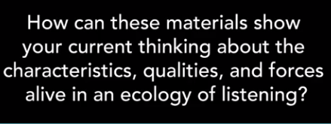

The piece of art is not the goal, the process is the goal. We capture the creations, and more importantly, a moment in time during the process, with photography.

Alternately, you can document your shadows by lightly tracing them onto paper. Next week, we will use watercolours to add to the thinking we did with paper and shadows.

Now, we will continue to process and refine our theories through writing. We are going to do an artist statement. 1) How does your creation illustrate your thinking? 2) What metaphors live inside your sculpture and the shadows that it creates? 3) What did you notice as you used paper, light, and shadow to explore this question? What might be the implications of that to your practice?

What is it like to create an artist statement a 2nd time? How has your comfort and understanding of an ecology of listening shifted? How are you able to dig a little deeper this time?

*Build on and grow your thinking and understanding about big questions by moving between the different languages of materials. Before you think with materials, play with them to uncover what they can do.

Thinking With Materials: Watercolour
Another opportunity to explore these ideas through materials!
Find your paper with the tracing of your paper sculpture shadow from last week. Next, collect watercolor paints or pencils, several pieces of paper (thicker paper is better), a paintbrush or three, a water jar, masking tape, blotting towel, and a placemat of some kind.
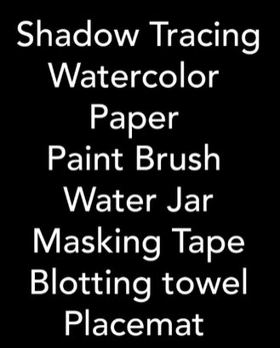
What can watercolour do?
- How does watercolour respond differently to wet vs. dry paper?
- Play around with how much pressure you put on the brush as you paint.
- Play around with how much water is on the brush before you put the paint on it.
- What happens when you try to overlap the colours?
- Notice what emotions you associate with the experience. What are the feelings you connect to the different colours and shapes?
Thinking With Watercolour:
Note: Don’t fall into the trap of believing that your watercolour will turn out exactly how you imagine it. Watercolour, like life, can take unpredictable twists and turns. Plan to be surprised.
1. What did you notice as you used these materials to explore this question? What might be the implications of that to your practice?
2. What is your artist's statement? How does this creation reflect and deepen your thinking?

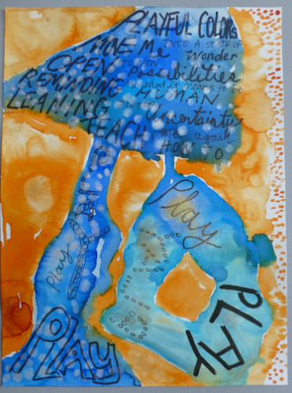
Playing with the Shape of Words
- Here, we play with the shape of words to develop new meaning.
- We start by exploring different pens to begin drawing with words.
- Next, we apply these tools to the notes we've been taking throughout the course.
- Then, we take those words into the shadow space from the watercolor painting we created in last week's exploration.
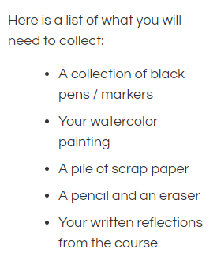
Take some time to test all of your different markers.
- Write the same word big and small.
- Which one of these makes the darkest marks?
- The lightest marks?
- Which ink might stand out from all of the others?
Now we can use these markers as our drawing tools.
- Start by pulling out a piece of scrap paper and draw (any) shape on it.
- Choose one marker and fill the shape with one word.
- Grab another piece of paper and draw the same shape.
- This time write the same word many different times and ways to fill up the space.
- As you write, zoom in on the different feelings they conjure up depending on the different ways you write the word.
- On another piece of paper, draw a shape and use a pair of words to fill up the shape. (ie: Love and Hope)
- Keep playing.
- How might you play around with how thick or thin the words are?
- How might you play around with different fonts?
Now reflect on your learning and deconstruct your reflections into words you can add to your watercolour painting.
We will use the tool of translation to change one type of writing to another.
Read through your writing. Highlight and circle words you wrote about. Try to only select a few words. Pick three words you want to zoom in on. Repeat with different sections that you wrote about.
List all the words on a separate piece of paper. The words on your poem will come from this list. Combine these words in new and different ways. Trim or add to the list as you go. You can remove the endings of words. Add pronouns, conjunctions, etc…
Fill up the whole space of the shadow space in your watercolour.
