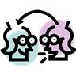 | STRATEGY FOR IMPROVING COMPREHENSION  SAY SOMETHING
Purpose:
- practice oral language – speaking and listening & conversation skills
- reinforce comprehension; think about content; clarify thinking through conversation
- encourage direct references to text for meaning and intent
- model think aloud; model academic language; model language of criticism, and other applications related to developing appropriate language

Implementation:
Example #1 -
1. Students work in pairs or groups of three. After the teacher stops reading, they take turns responding with their ‘say something’ cards to comment on what was just read.

The speaker does at least one of the following:
• makes a prediction ("I wonder if ...")
• poses a question for information ("What will happen next...?")
• suggests a clarification ("That makes sense because...")
• comments on the content ("I liked it when the writer said...")
• connects the content to something else ("This reminds me of...")

2. After the conversation, the teacher will read some more and another member of the group will "say something".

3. The group repeats the process.

Predictions | Questions | Clarifications | Comments | Connections
- I wonder… | - Who?  - What?  - Where?  - Why?  - How? | - Now I understand because… | - I like the part where…  - I don’t understand … | - This reminds me of …  - A book I read  - A time that I…

Example #2 –
The “cue” cards (above) (full-sheet copies follow) can be used as conversation starters during the lesson. Simply stop and ask students to turn to their partners and “Say something.”

The sentence starters can also be used to: a) comment on artistic works b) comment on music c) provide evidence for our thinking etc…

STRATEGY FOR IMPROVING COMPREHENSION
SAY SOMETHING
Success: Observe informally and/or note on rubric whether students -
- make meaningful and relevant inferences in conversation
- predict next steps and ask questions
- visualize events and characters
- make connections to other works, subjects, or personal experiences
- transfer the academic language to writing and speaking after this practice

Assessment:

Methods:
self-assessment; peer assessment; teacher observation; self-reflection

Example of Teacher observation
Ken, Sharma and Joe are asking some good questions when they pause, although Joe seems to be having trouble thinking about what might come next. Claire refers to her cue cards every time she says something.

Methods:
criteria checklists; anecdotal information; portfolio; note-checking; oral language rubrics; writing rubrics

Example of Anecdotal information
"Say Something" lets me see where the needy students are in this class. At the breaks in conversation, some students — e.g., Leah and Marco — have difficulty thinking about what to say, even with the prompts on the board and on the cue cards. I need to work with them to shore up their comprehension strategies. One student, Claire, will need to have a personal copy of the sentence starters or stems to use in her reflection and more formal writing.

PREDICTIONS | PREDICTIONS | PREDICTIONS
- I wonder if …  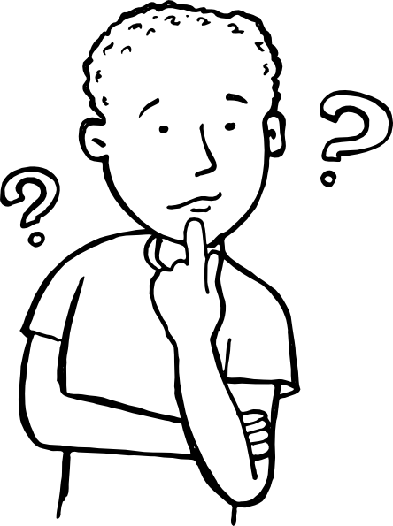 | - I wonder if … | - I wonder if …
PREDICTIONS | PREDICTIONS | PREDICTIONS
- I wonder if … | - I wonder if … | - I wonder if …
PREDICTIONS | PREDICTIONS | PREDICTIONS
- I wonder if … | - I wonder if … | - I wonder if …

QUESTIONS | QUESTIONS | QUESTIONS



QUESTIONS | QUESTIONS | QUESTIONS
QUESTIONS | QUESTIONS | QUESTIONS

CLARIFICATIONS | CLARIFICATIONS | CLARIFICATIONS
- Now I understand because…  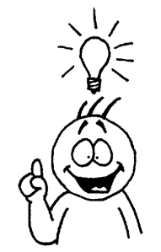 | - Now I understand because… | - Now I understand because…
CLARIFICATIONS | CLARIFICATIONS | CLARIFICATIONS
- Now I understand because… | - Now I understand because… | - Now I understand because…
CLARIFICATIONS | CLARIFICATIONS | CLARIFICATIONS
- Now I understand because… | - Now I understand because… | - Now I understand because…

COMMENTS | COMMENTS | COMMENTS
- I like the part where…  - I don’t understand …  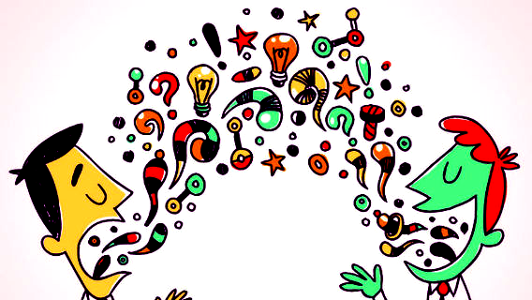 | - I like the part where…  - I don’t understand … | - I like the part where…  - I don’t understand …
COMMENTS | COMMENTS | COMMENTS
- I like the part where…  - I don’t understand … | - I like the part where…  - I don’t understand … | - I like the part where…  - I don’t understand …
COMMENTS | COMMENTS | COMMENTS
- I like the part where…  - I don’t understand … | - I like the part where…  - I don’t understand … | - I like the part where…  - I don’t understand …

CONNECTIONS | CONNECTIONS | CONNECTIONS
- This reminds me of…  - A book I heard  - A time that I…   | - This reminds me of…  - A book I heard  - A time that I… | - This reminds me of…  - A book I heard  - A time that I…
CONNECTIONS | CONNECTIONS | CONNECTIONS
- This reminds me of…  - A book I heard  - A time that I… | - This reminds me of…  - A book I heard  - A time that I… | - This reminds me of…  - A book I heard  - A time that I…
CONNECTIONS | CONNECTIONS | CONNECTIONS
- This reminds me of…  - A book I heard  - A time that I… | - This reminds me of…  - A book I heard  - A time that I… | - This reminds me of…  - A book I heard  - A time that I…

